Ideation Phase
Empathize & Discover

Date | 31 January 2025
Team ID | SWTID-2026-2491
Project Name | AI BlogNest API
Maximum Marks | 4 Marks

Empathy Map Canvas:
AI BlogNest API users think about creating content and consistently. They feel pressure to publish and want automation. They hear feedback from readers, clients, teams, and communities about content. They see writing tools, publishing platforms, workflows, and AI solutions. They say and do: write articles, generate ideas, edit drafts, schedule posts, and manage content through APIs. Their pains are time-consuming writing, repetitive tasks, disconnected tools, and difficult management. Their gains are faster creation, automation, consistent quality, integration, and scalable publishing.
Example:
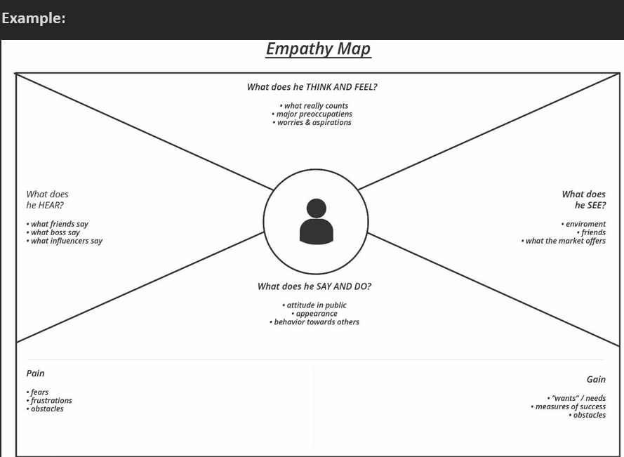

Example: Food Ordering & Delivery Application
